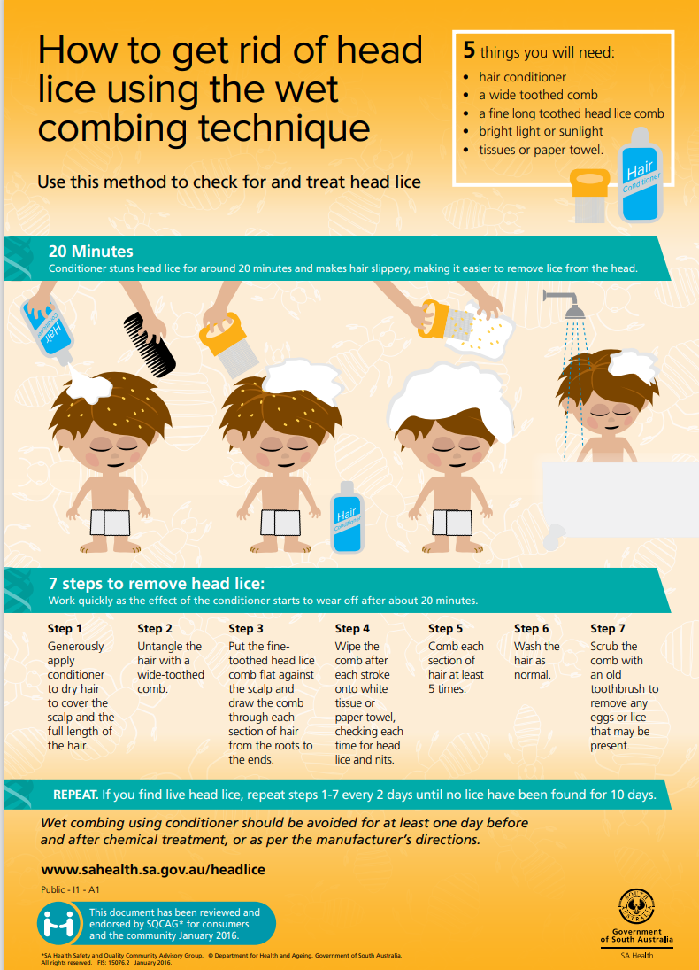
ES42C: Wet Combing Technique

Applicable to Community Language Schools SA and all member schools

